**CSA1054 Software Engineering**

**LAB EXPERIMENTS**

**NAME: K. Siva Naga Manoj Kumar**

**Reg number: 192111630**

**EXPERIMENT NUMBER 1:** Design an activity diagram for an automated online banking system which shows the flow of type of account, withdrawal, deposit, balance enquiry and check whether the person has a loan. If there is a due in loan then push the notification “pay the due amount.

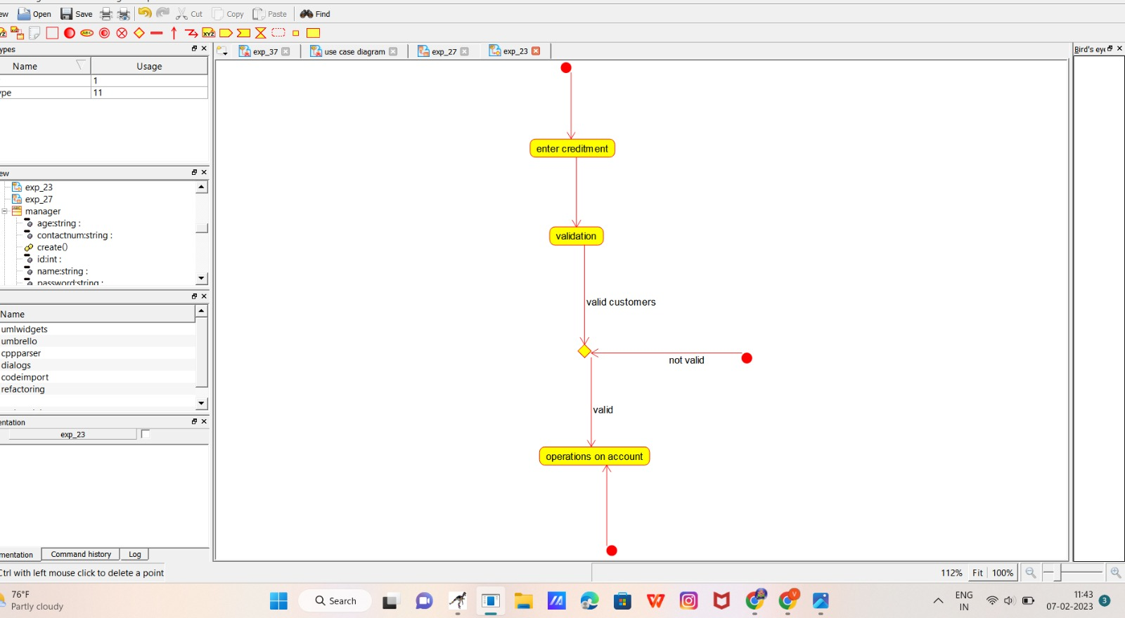**EXPERIMENT NUMBER** 2:Take for example the RSA encryption system: All arithmetic is done modulo n, with n=pq and p, q large primes. Decryption in this system relies on computing Euler's phi function, φ(n), which is hard to compute (hence the system is hard to break) **unless** you know the prime factorization of n (which is also hard to compute unless you know it upfront). Hence you need a method to generate primes (the Miller-Rabin primality checking algorithm is usually used here) and then you construct n by multiplying the primes you have found. Using Raptor, draw the flowchart to find whether p and q are prime or not.

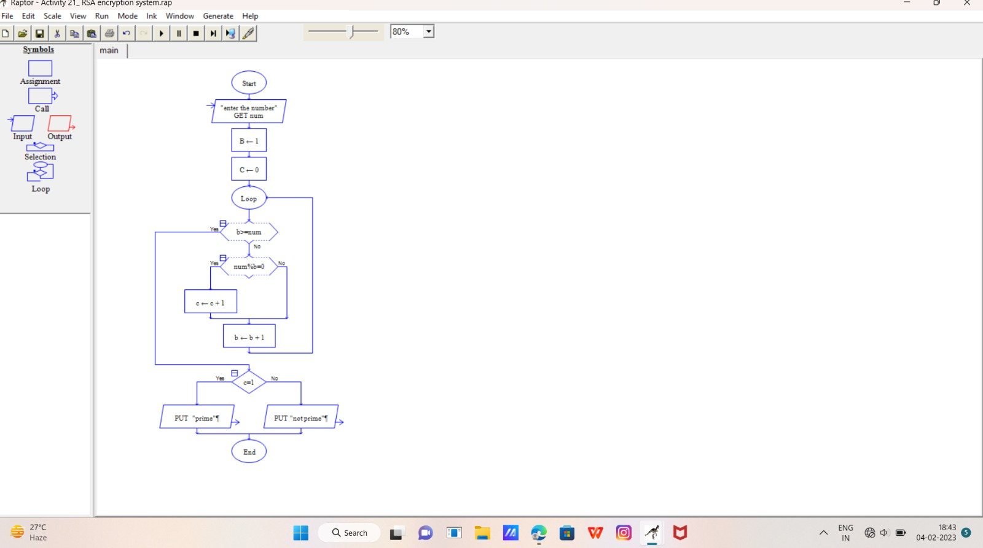

**EXPERIMENT NUMBER3:** Make a class diagram to model for a quiz system. A user can request a quiz for the system. The system picks a set of questions from its database, and composes them together to make a quiz. It rates the user’s answers and gives hints if the user requests it. In addition to users, we also have helpers who provide questions and hints. And also administrators who must certify questions to make sure they are not too trivial and those they are correct.

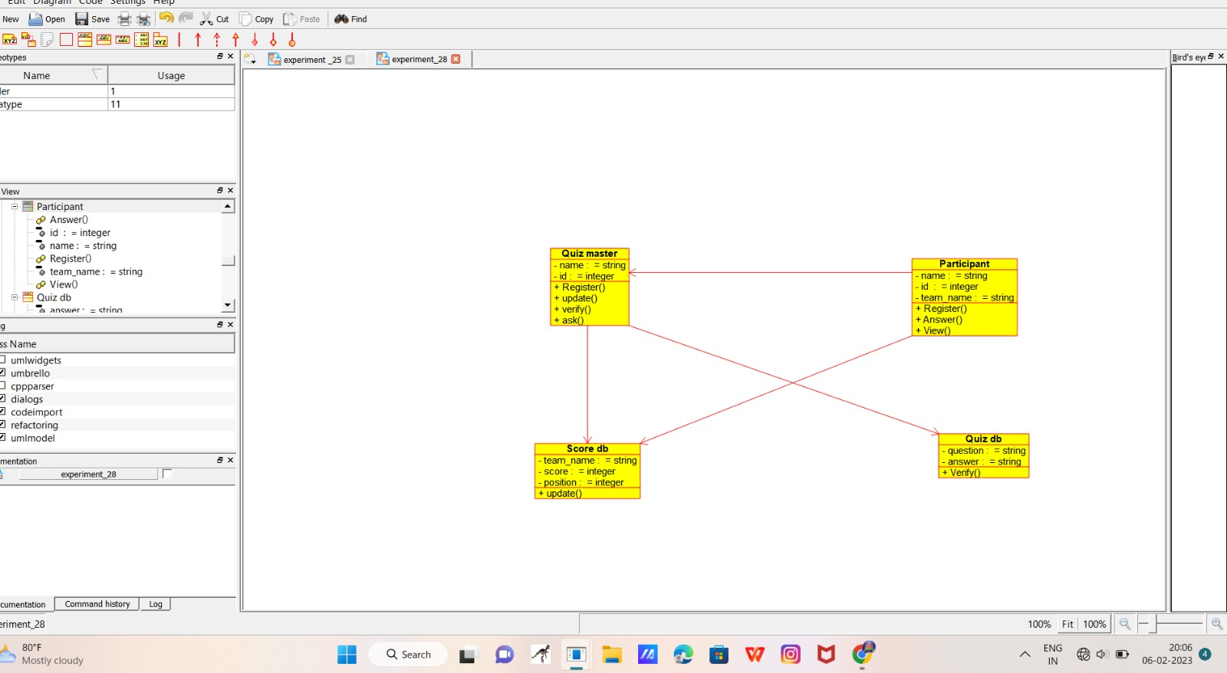

**EXPERIMENT NUMBER4:** Using Raptor – Draw and validate the flowchart to find odd series of the given number. The odd numbers are the numbers which are not divisible by 2. They are 1,3,5,7,9,11,13,15,17,19 etc.. Using Raptor – Draw and validate the flowchart to find even series of the given number

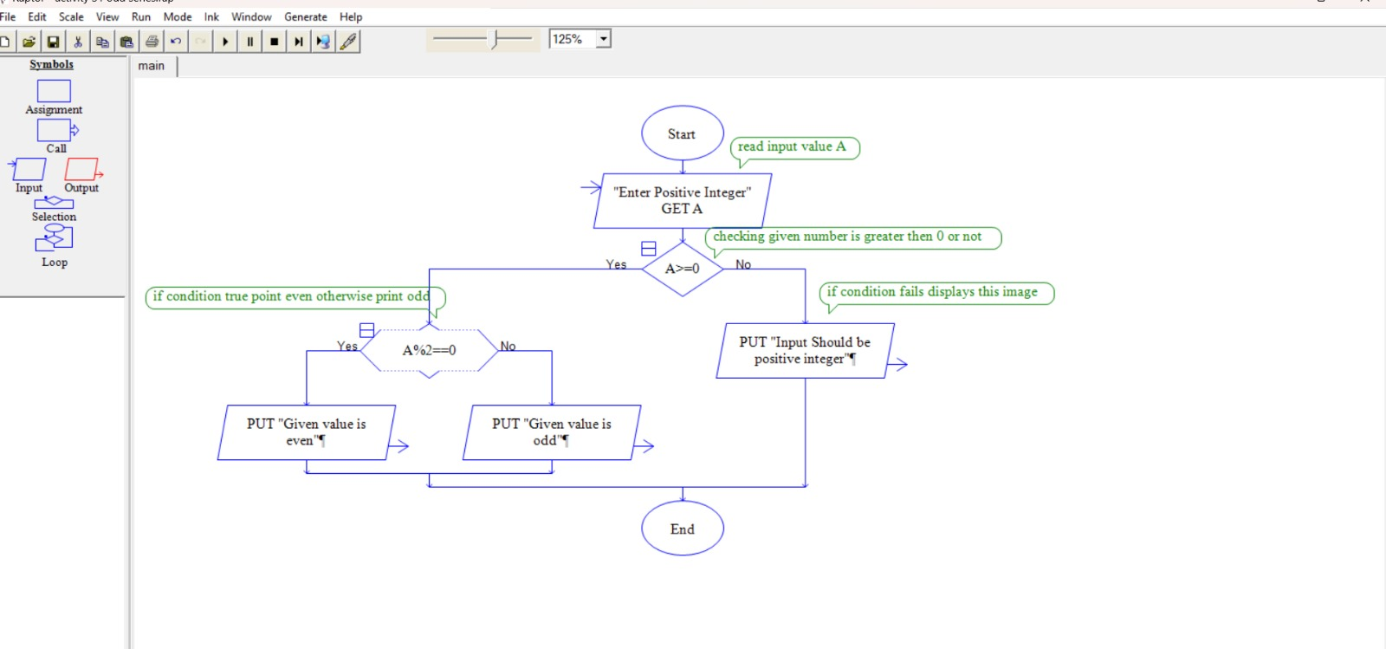

**EXPERIMENT NUMBER5:** Construct a flowchart using raptor and Check whether a string is palindrome or not a palindrome is a word, number, phrase, or other sequence of symbols that reads the same backwards as forwards, such as the words madam or race car

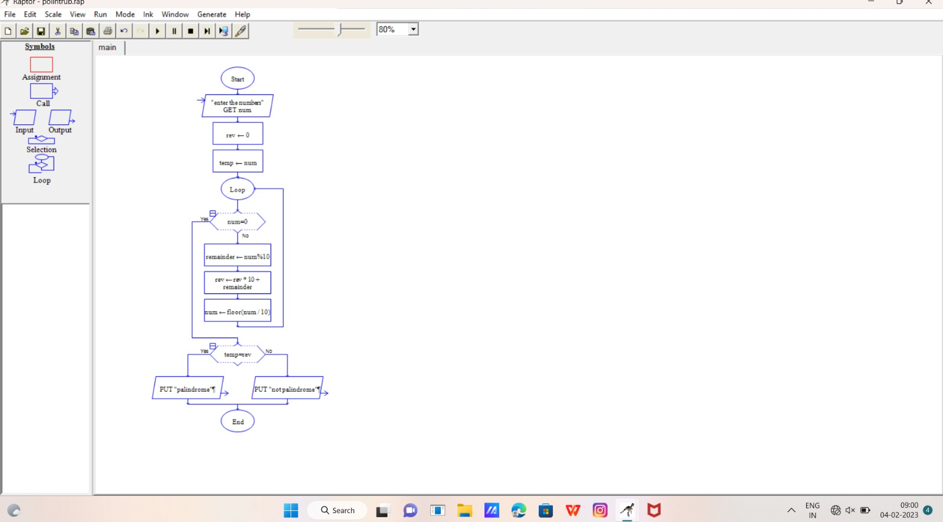

**EXPERIMENT NUMBER 6:**

Using Raptor- Draw the flowchart to check whether the given number is a palindrome or not. This scenario is a word, number, phrase, or other sequence of symbols that reads the same backwards as forwards. AdaptA method for this problem is to reverse digits of number, compare the reverse of number. If both are same, then return true, else false using Raptor tool

 **EXPERIMENT NUMBER 7:** activity diagram for Hospital management system

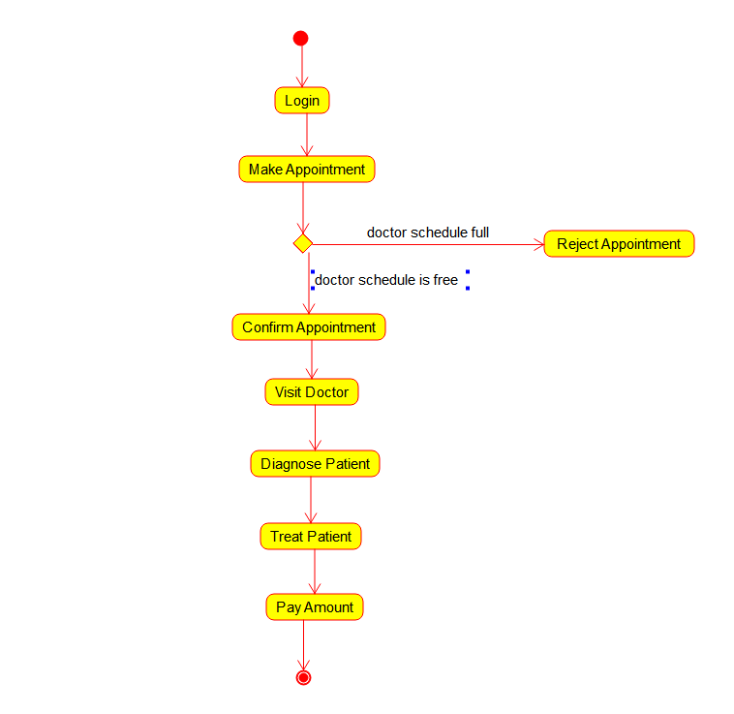

**EXPERIMENT NUMBER 8:** activity diagram for e-ticketing

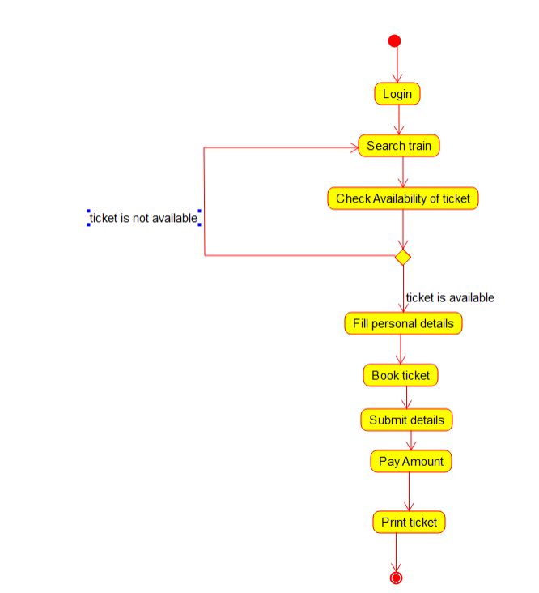

**EXPERIMENT NUMBER 9:**

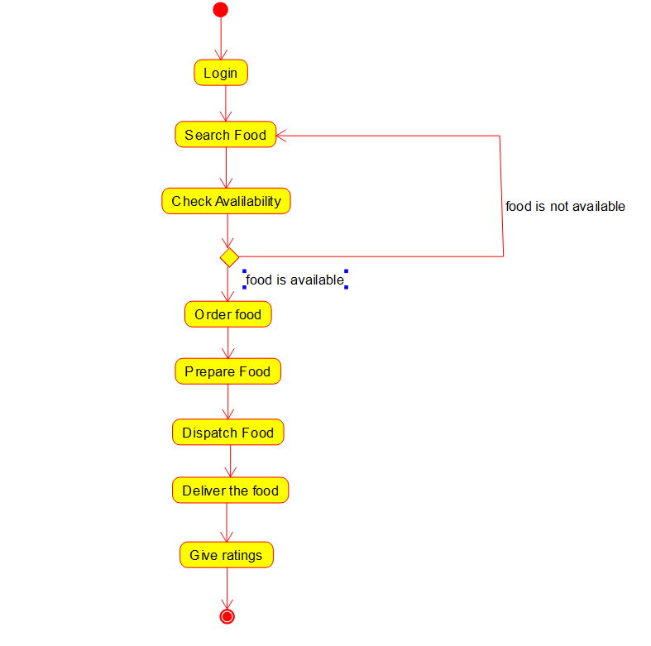

**EXPERIMENT NUMBER 10:** Draw a flowchart to display the position of the number and validate the process flow using raptor

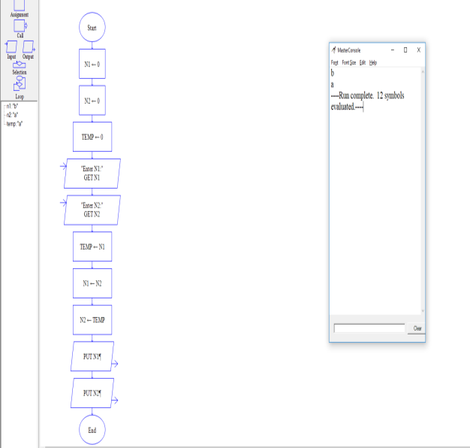

**EXPERIMENT NUMBER11:** Draw a flowchart for finding given number is prime or not and validate the process flow using

RAPTOR.

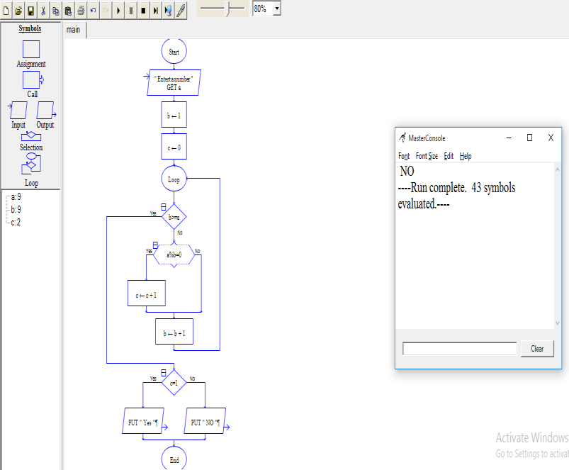

**EXPERIMENT NUMBER12: Find Cyclomatic Complexity for a graph having number of edges as**

**12,**

**number of nodes as 13 and number of predicate nodes in the flow graph as 5**

#include<stdio.h>

#include<conio.h>

void main()

{

int E,N,P,CC;

clrscr();

printf(“\n Program to find Cyclomatic Complexity:”);

printf(“\n Enter the number of Edges in the flow graph:”);

scanf(“%d”,&E);

printf(“\n Enter the number of Nodes in the flow graph:”);

scanf(“%d”,&N);

printf(“\n Enter the number of Predicate Nodes in the flow graph:”);

scanf(“%d”,&P);

CC = E – N + (2*P);

printf(“\n The Cyclomatic Complexity of the flow graph is : %d”, CC);

getch();

}

**EXPERIMENT NUMBER13: UML DIAGRAM FOR E-TICKETING SYSTEM**

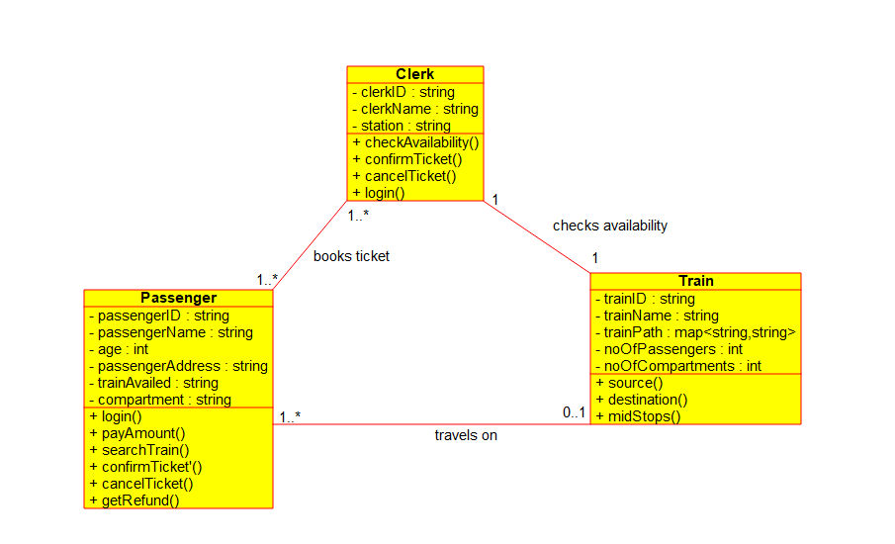

**EXPERIMENT NUMBER 14:** activity diagram for Hospital management system

using Umbrello.



**EXPERIMENT NUMBER 15:** Draw a Activity diagram for Online Voting System for a software platform that allows groups to securely conduct votes and elections using CASE tools. The voters should be able to register via some proper authority. Construct a system in which the voters should see the list of candidates present in his constituency. A voter should be able to cast his vote to a candidate and that voter should cast only 1 vote at a time Draw an Activity diagram for Library Management System using CASE tools.

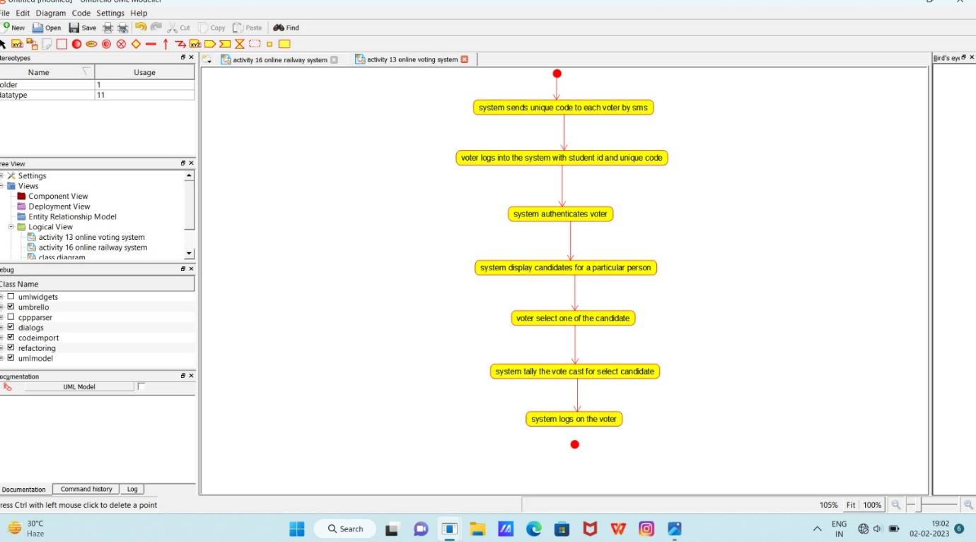

**EXPERIMENT NUMBER 16:**

**flowchart to calculate factorial**

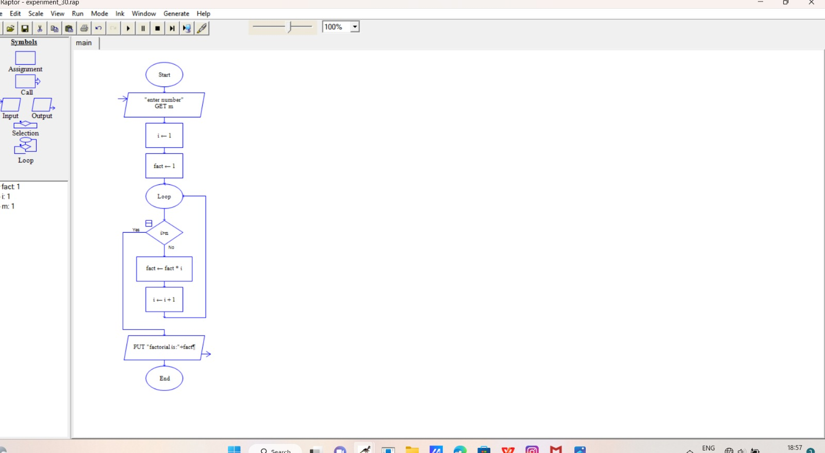

**EXPERIMENT NUMBER17: Flowchart of string handling**

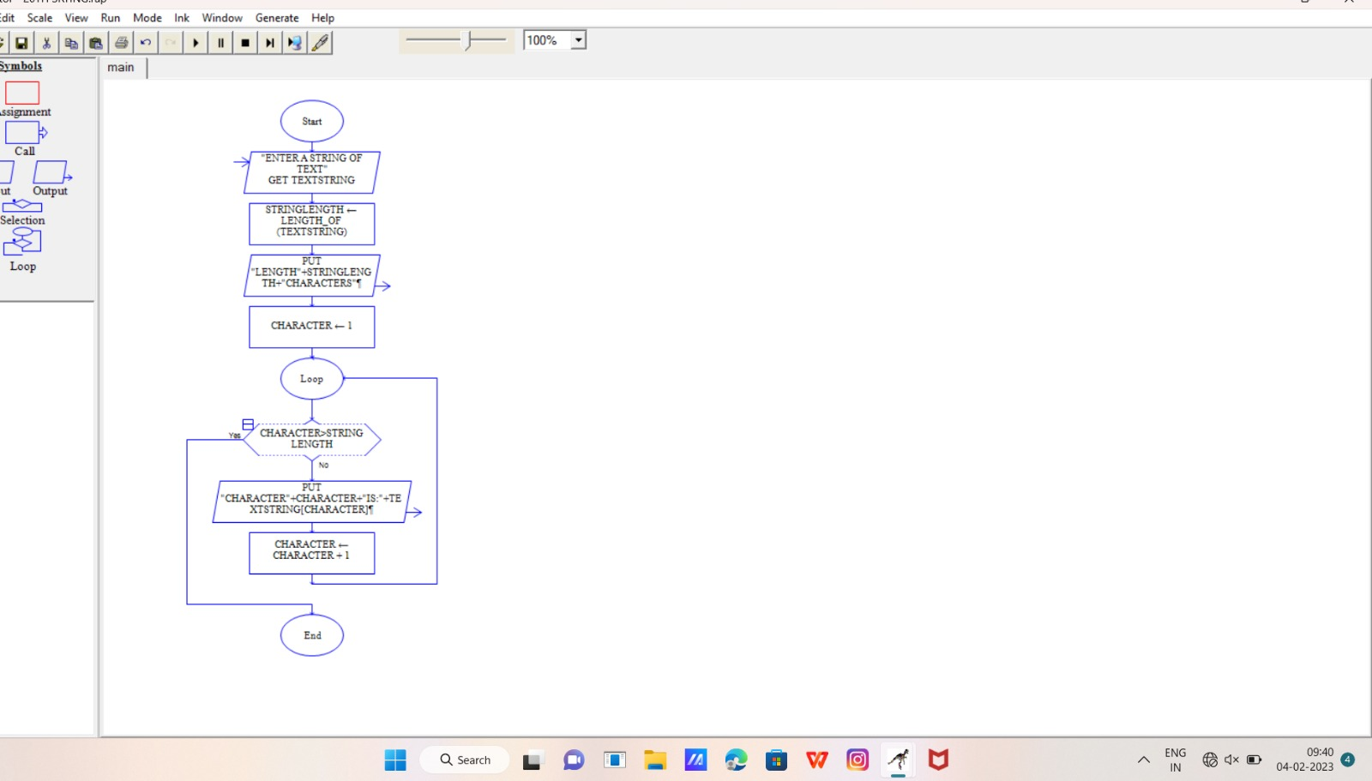

**EXPERIMENT NUMBER18: Flowchart of reverse of string**

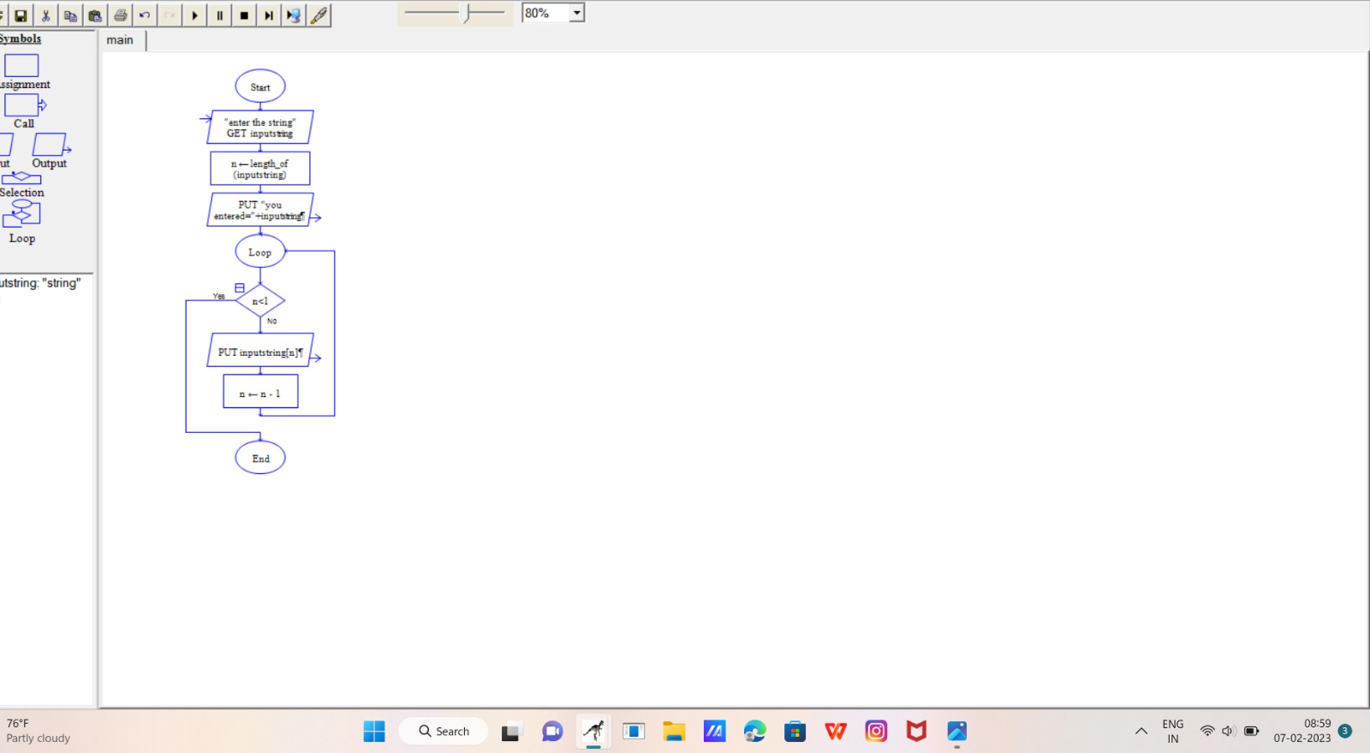

**EXPERIMENT NUMBER19: Flowchart of dividend**

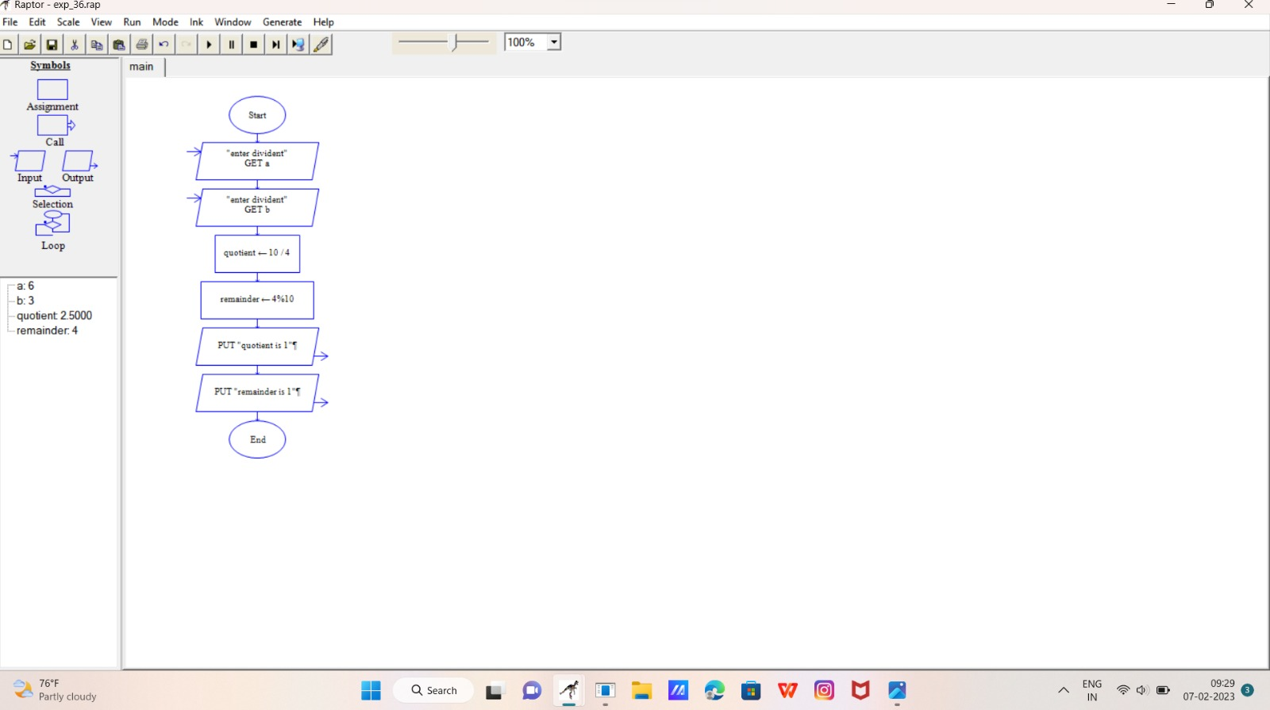

**EXPERIMENT NUMBER20: Flowchart of natural numbers**

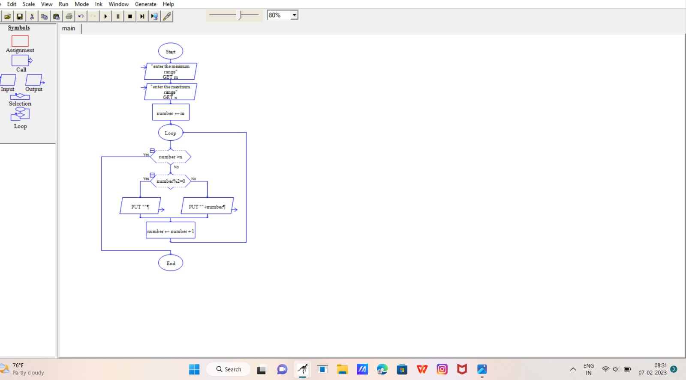

**EXPERIMENT NUMBER 21: Flowchart of fibonacci series**

